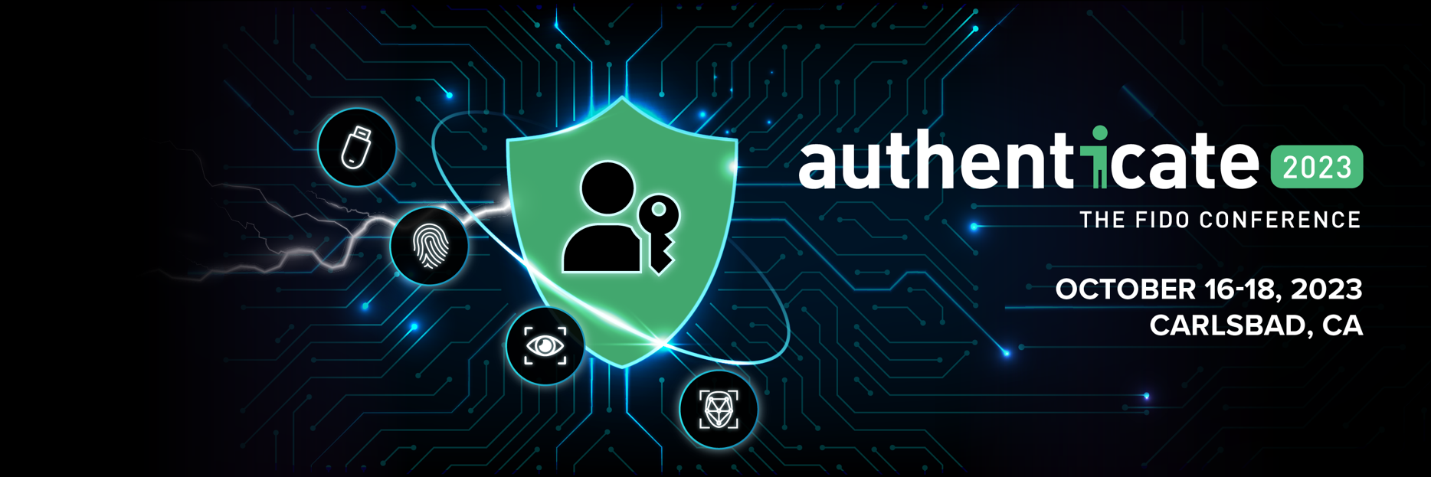
Authenticate 2023 Call for Speakers Offline Form
Submission Deadline: March 31, 2023
Questions? authenticate@fidoalliance.org
Submit: https://authenticatecon.com/authenticate-2023-call-for-speakers/

Authenticate is the industry’s only conference dedicated to all aspects of user authentication – including a focus on FIDO-based sign-ins. It is the place for CISOs, business leaders, product managers, security strategists and identity architects to get all of the education, tools and best practices to roll out modern authentication across web, enterprise and government applications.

The committee is looking for vendor-neutral, educational presentations that focus on authentication strategies and best practices. Submissions can span all aspects of authentication implementations from initial research and business case development through piloting to rollout and beyond. Perspectives on global trends and considerations for user authentication should also be submitted.

The committee is looking for a variety of session types and formats including main stage storytelling, introductory “101’s”, detailed case studies, technical tutorials, hands-on labs, and thought provoking panels in these formats:
- Main stage – insightful stories that will get the audience thinking, or perhaps re-thinking, how they approach authentication; typically 20 minutes
- Panel – lively discussions on pertinent and/or controversial authentication topics; typically 45 minutes
- Single speaker presentation – track sessions with actionable authentication content; typically 20 minutes
- Dual-speaker presentation – track sessions with actionable authentication content; typically 20 minutes
- Hands-on lab – interactive education sessions that gives attendees the opportunity to build and improve their skills and/or knowledge on a particular aspect of authentication; typically 90 minutes

Topic areas of interest include:
- Authentication trends & insights
- Modern authentication case studies & implementation strategy
- Hands-on implementation guidance & best practices (such as workshop, tutorials, and labs)
- Government impact on authentication
Other topic areas related to authentication will be considered. Submissions that are unique, expertise-driven and reflect diversity in speakers are most likely to be accepted. Product or sales pitches will not be accepted.
The Authenticate Call for Speakers closes on March 31, 2023. It’s strongly suggested to submit your ideas early, as the program committee will review proposals as they are submitted.
Please note that you’ll be required to create an account to submit an abstract. **Accounts must be created with the actual speaker details to avoid confusion in the review process.
To submit, visit https://authenticatecon.com/authenticate-2023-call-for-speakers/

ONLINE FORM DETAILS:
- First Name*
- Last Name*
- Company Name*
- Title*
- Email Address*
- Support person email address (if applicable)
- Mobile Phone*
- Address
- Country*
- Zip Code
- Bio*
- Headshot*
- LinkedIn Profile*
- Please specify the gender you identify with*
  - Female
  - Male
  - Non-binary
  - 3rd gender
  - Prefer not to answer
  - None of these options apply to me
- Add additional speaker information (name, title, company and bio) for dual or panel presentations here:

* By entering this submission you agree to the Speaker Agreement. (See Appendix 1.) (Checkbox required on online form).

- Topic Area (Drop-down menu) (Choose one):*
  - Authentication trends & insights
  - Modern authentication case studies & implementation strategy
  - Hands on implementation guidance & best practices (such as workshop, tutorials, and labs)
- Government impact on authentication
- Presentation Type*
  - Main stage – insightful stories that will get the audience thinking, or perhaps re-thinking, how they approach authentication; typically 20 minutes
  - Panel – lively discussions on pertinent and/or controversial authentication topics; typically 45 minutes
  - Single speaker presentation – track sessions with actionable authentication content; typically 20 minutes
  - Dual-speaker presentation – track sessions with actionable authentication content; typically 20 minutes
  - Hands-on lab – interactive education sessions that gives attendees the opportunity to build and improve their skills and/or knowledge on a particular aspect of authentication; typically 90 minutes
- Submission Title*
- Submission Description short (approximately 100-150 words)* (500 character max )
- Submission Description full (approximately 1000 words)* (no character max)
- Takeaway 1
- Takeaway 2
- Takeaway 3

Appendix 1
Speaker Agreement
- I am able to present in-person at Authenticate 2023 ("Authenticate" or "the event"), being held October 16-18, 2023, in Carlsbad, California USA. (If your presentation is accepted, you will be given a specific speaking date/time upon agenda finalization) OR I am able to pre-record an on-demand session at an agreed upon date/time.
- I understand that if my proposal is accepted, the day and time of my speaking spot will be assigned by the Authenticate Program Committee.
- My presentation will not include product pitches or vendor-biased content.
- I will submit my presentation for review and approval by the Authenticate Program Committee on time (typically one month prior to Authenticate).
- I agree to use the Authenticate-branded title and closing slides for my presentation.
- I understand and agree that my presentation title, abstract, bio, headshot and social media details (if provided) will be used on the Authenticate website and in other event-related promotional and agenda material.
- I understand and agree that my email address will be used by Authenticate organizers to communicate with me about the event.
- I understand and agree that my presentation at Authenticate will be filmed and the presentation may be made generally available as part of the post-event material. I also understand that I can opt out of having my presentation made available to the public by submitting a request to authenticate@fidoalliance.org.
- I agree that if I fail to meet the requirements and deadlines provided to me, my speaking spot may be reassigned to another speaker.

